CL 2006 OPERATING SYSTEM
BS Software Engineering
Spring-2026




Lab 11: Threads

Threads:
A thread is a smaller unit of a process that can be executed independently. A process can have multiple threads, all sharing the same memory space but executing different parts of the program simultaneously.
Imagine a cooking task: if you have multiple cooks (threads), they can each focus on a specific task (one chops vegetables, another boils water). They all work together towards a common goal (preparing the meal).
In programming, threads allow us to split tasks so they can run in parallel, which can make programs faster and more efficient.

pthread_create:
This function is used to create a new thread.

Syntax:
int pthread_create(pthread_t *thread, const pthread_attr_t *attr, void *(*start_routine) (void *), void *arg);

thread: The identifier for the new thread.
attr: Specifies attributes (can be NULL for default settings).
start_routine: The function the thread will execute.
arg: A pointer to arguments passed to the function (can be NULL).

Return Value:
Returns 0: If the thread was successfully created.
Returns a non-zero value: If an error occurred (e.g., insufficient resources).

Example:
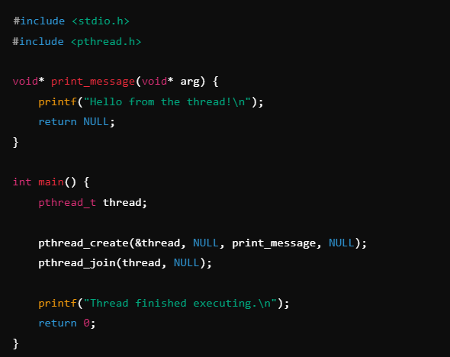
In this example, pthread_create creates a new thread that runs the print_message function.

Output:
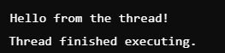

pthread_self:
pthread_self() returns the ID of the calling thread.

Example:
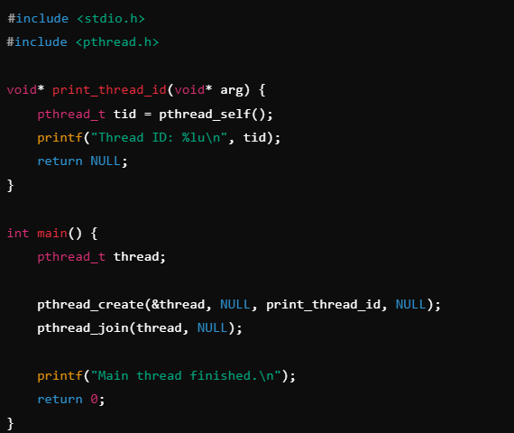

In this example, the thread prints its own ID using pthread_self().

Output:
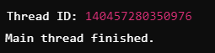

pthread_join:
This function makes the calling thread (usually the main thread) wait until another thread terminates.

Return Value:
Returns 0: If the call completed successfully.
Returns a non-zero value: If an error occurred (e.g., invalid thread ID).

Syntax:
int pthread_join(pthread_t thread, void **retval);
thread: The thread to wait for.
retval: Pointer to the return value of the terminated thread (can be NULL).

Example:
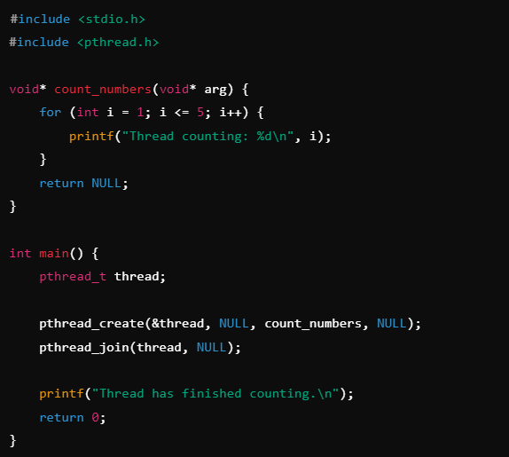
Here, pthread_join ensures the main thread waits for count_numbers to finish before printing the final message.

Output:
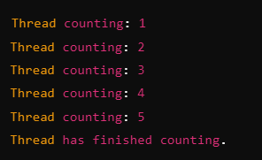

pthread_exit:
pthread_exit() is used to terminate the calling thread. It allows a thread to exit without affecting the process or other threads.

Syntax:
void pthread_exit(void *retval);
retval: The return value of the thread (can be NULL).

Example:
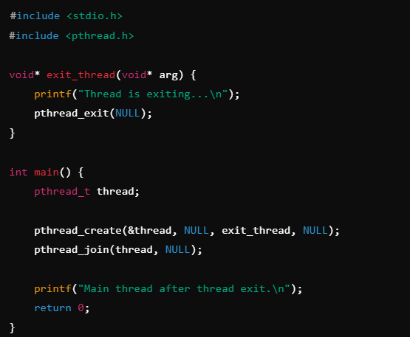
Here, the pthread_exit function terminates the thread, and the main thread waits for its completion using pthread_join.

Output:
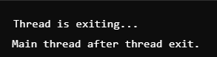

pthread_join() and pthread_exit with non null arguments:
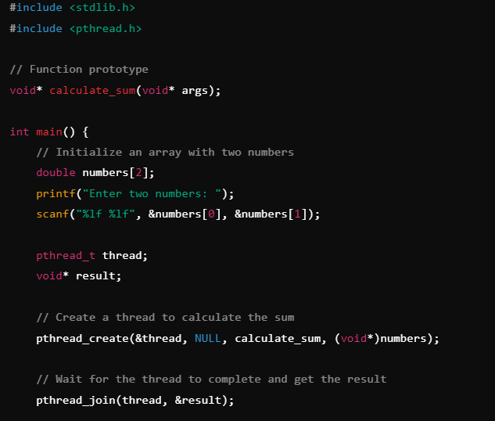
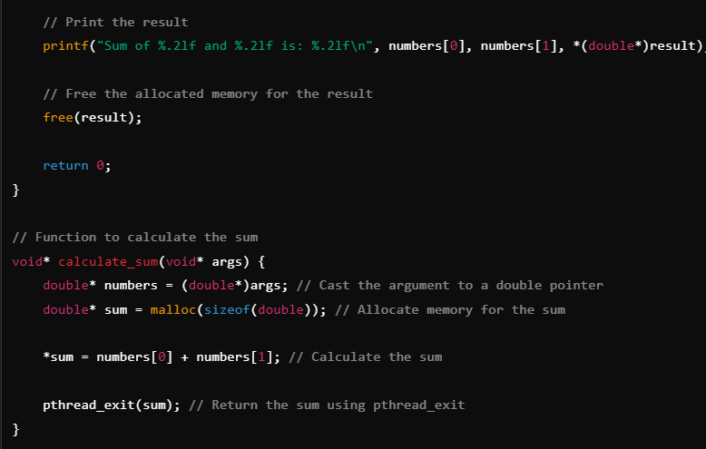

Output:
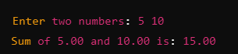

Tasks:

- Create a program where multiple threads print "Hello from thread X", where X is the thread number. ( 20 mins )
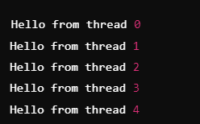
- Create a program where array is pass to a thread and thread calculates the sum of elements in array and displays it. ( 25 mins )
- Modify task 2, where threads calculates the sum and return the result to main thread (main function) and displays the sum in main function. (don’t use global variables). Use pthread_exit. ( 15 mins )
- Write a program that creates a thread to find the maximum value in an array. The array should be passed to the thread, and the maximum value should be returned from the thread. No global variables should be used. Don’t use pthread_exit. ( 20 mins )

Task Submission Guidelines:
- Make a word document and paste the code with output’s screenshot there and save it as pdf or odt.
- Include your name and roll no. at the front page.
- Files other than pdf or odt will not be accepted and will be marked as 0.
- Along with each task solution, also upload the screenshot of the output

